- 1. What are the main components of software cost / Parameter to compute total cost of software development?

- Answer:
- Hardware and software costs (including maintenance).
- Travel and training costs.
- Effort costs (like salaries, social and insurance costs).
- Overhead costs like building, lighting, networking, and shared facilities.

- 2.What are the main factors that affect software pricing?

- Answer:
- Market Opportunity: Prices may be kept low to enter new markets.
- Unclear Costs: Extra cost is added if it’s hard to guess the total expense.
- Contract Rules:Price can change depending on who owns the software.
- Changing Needs:f customer needs change later, prices may go up.
- Company’s Money Situation: A company in financial trouble might offer lower prices to win projects.

- 3. What is software cost estimation / Estimation Techniques?

- Answer: Estimation tells us how much money, time, and resources will be needed to build a system or product.

- It is based on: -
- Past data/experience
- Available documents/knowledge
- Assumptions
- Identified risks

- 4. What is algorithmic cost modeling / Process of algorithm cost modelling?

- Answer: It is a mathematical method to estimate software costs using project size, team size, and other attributes.
- Formula:
- Effort = A ∗Size^B ∗ M
- A is a constant.
- Size is the software size (in LOC, function points, etc.).
- B is an exponent (usually 1 to 1.5).
- M is a multiplier based on project and team attributes.

- 5. What are the difficulties of algorithmic cost models?
- Answer:

- 1. Size is hard to estimate early—code size or function points may be inaccurate.
- 2. B and M are subjective—different people give different values based on experience and system type.

- 1. What is COCOMO?

- COCOMO is a model used to estimate the time and effort needed to build software.

- 2. What does COCOMO estimate?

- It estimates:
- Effort (how many people and months)
- Time (how long to finish the project)

- 3. What inputs does COCOMO need?

- Size of software (in KLOC – 1000 lines of code)
- Project type
- Cost drivers (things that affect productivity)

- 5. What are the 3 project types in COCOMO / Where COCOMO model applied?

- Organic:
- Simple project
- Small team
- Experienced people

- Semidetached:
- Medium difficulty
- Mixed team (some new, some experienced)

- Embedded:
- Very complex
- Tied to hardware
- Strict rules

- 6. What is the formula used in the Basic COCOMO model?

- Effort (PM) = a × (KLOC)^b
- Development Time (Tdev) = c × (Effort)^d

- Example Problem

7. A project is estimated to be 400 KLOC. Calculate effort and development time for all three modes.

- Let’s use the formulas:

- Effort = a × (KLOC)^b
- Tdev = c × (Effort)^d

- Given: KLOC = 400

- 1. Organic Mode (a = 2.4, b = 1.05, c = 2.5, d = 0.38)

- Effort = 2.4 × (400)^1.05 ≈ 1286.8 PM

- Tdev = 2.5 × (1286.8)^0.38 ≈ 38.3 months

- 2. Semidetached Mode (a = 3.0, b = 1.12, c = 2.5, d = 0.35)

- Effort = 3.0 × (400)^1.12 ≈ 2217.2 PM

- Tdev = 2.5 × (2217.2)^0.35 ≈ 43.0 months

- 3. Embedded Mode (a = 3.6, b = 1.20, c = 2.5, d = 0.32)

- Effort = 3.6 × (400)^1.20 ≈ 4136.0 PM

- Tdev = 2.5 × (4136.0)^0.32 ≈ 47.8 months

- 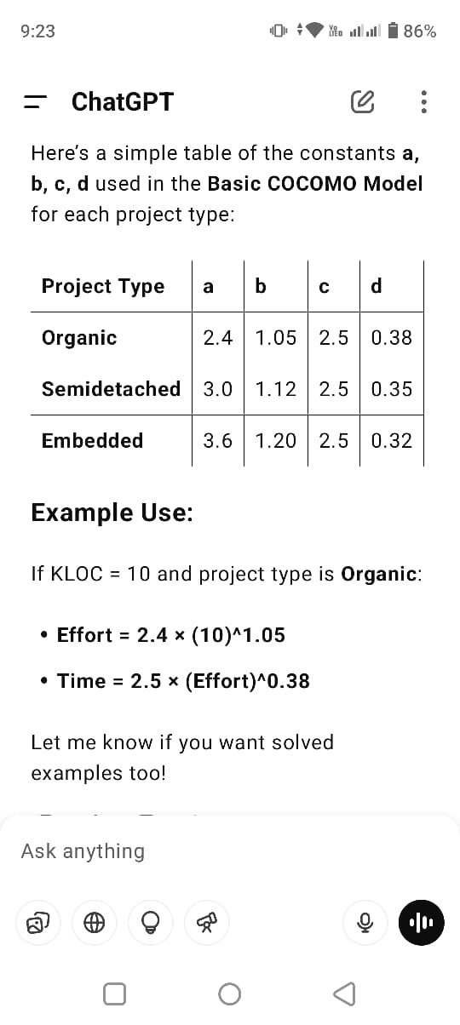

Extra Question:

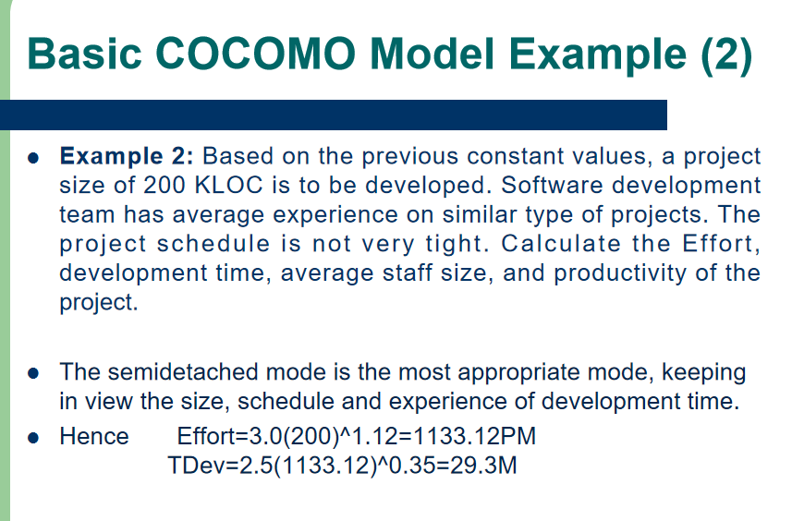

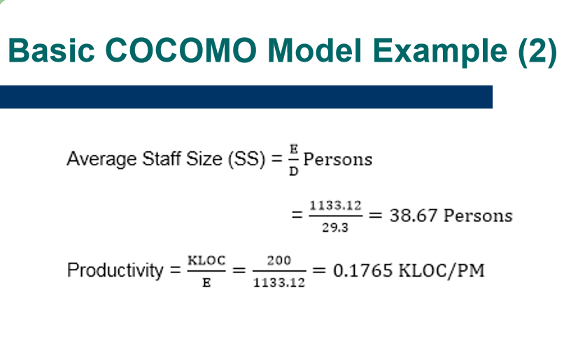

- Q1: What is the difference between COCOMO 81 and COCOMO II?

- Ans: COCOMO 81 is for old-style (waterfall) development from scratch. COCOMO II works for modern methods and reuse.

- Q2: What are the 4 sub-models of COCOMO II / COCOMO 2 sub-model designed,introduced or modified etc ?

- Application Composition Model – Based on reusable components.
- Early Design Model – Before design starts.
- Reuse Model – For effort needed to reuse software.
- Post-architecture Model – After design is available.

- Q3.What is Software Quality Assurance (SQA) ? (Keyword: Quality assurance,steps of QA,meaning of QA etc etc.)
- Ans:
- Makes Sure Software is Good:
- SQA is a process that checks if the software meets quality rules and works properly.
- Focuses on the Right Way of Working:
- It ensures the team follows correct steps and methods while building the software.
- Stops Problems Early:
- SQA helps find and fix mistakes early, so they don’t cause bigger issues later.
- Uses Checks and Reviews:
- It includes doing code reviews, testing, and audits to keep everything on track.
- Works in All Project Steps:
- SQA is used from the beginning of the project to the end, to keep quality high at every stage.

- Q4: What is Six Sigma?
- Ans: Six Sigma is a method that uses data and statistics to reduce defects and improve quality.

- Q5: What are the 3 steps in Six Sigma?

- Define– Know what the customer wants.
- Measure – Count problems (defects).
- Analyze – Find the main reasons for mistakes.

- Q6 : Core steps of improve or developed the six sigma.(Keyword: improve six sigma or developed steps of six sigma)
- Design defect-free process
- Verify process meets needs

- Q7: What is ISO 9000?

- ISO 9000 is a set of international standards on quality management and assurance developed to help organizations document and implement an effective quality system.

- Q8: What are the seven quality management principles of ISO 9000 / Principles of ISO 9000?

- 1. Customer focus
- 2. Leadership
- 3. Engagement of people
- 4. Process approach
- 5. Improvement
- 6. Evidence-based decision making
- 7. Relationship management

- Q1: What is SEI CMM model ? Explain the maturity level of CMM model.(Keyword: Maturity level of CMM model with diagram or without diagram)
- Definition: A method to measure the maturity of a software company’s processes (1 to 5 scale).
- Level 1 - Initial - Work is performed informally
- Level 2 - Repeatable - Work is planned & tracked
- Level 3 - Defined - Work is well-defined
- Level 4 - Managed - Work is quantitatively controlled
- Level 5 - Optimizing - Work is based upon continuous improvement

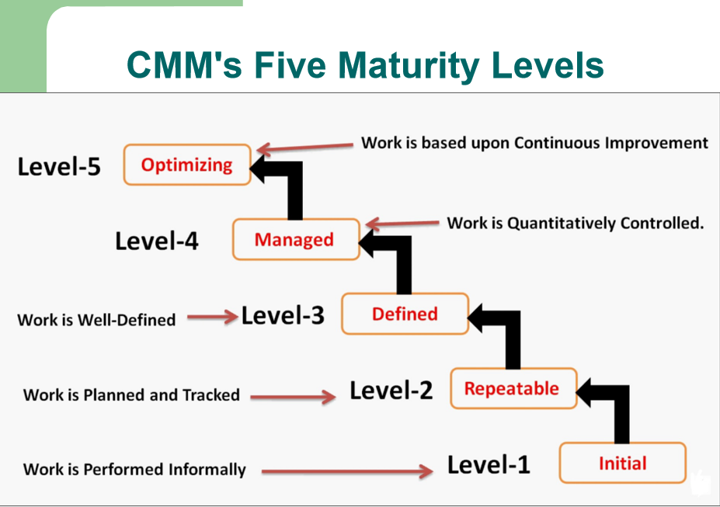

- Q2: What happens at Level 1 (Initial)?
- A4: At this level, the work is not planned. Everything depends on people, and there is no proper process. It is full of confusion.

- Q3: What happens at Level 2 (Repeatable)?
- A5: The company uses basic planning and management. Good work can be repeated because some processes are written down and followed.

- Q4: What happens at Level 3 (Defined)?
- A6: The company has its own standard way of working. The process is written clearly and used by all teams.

- Q5: What happens at Level 4 (Managed)?
- A7: The company starts measuring its work using numbers and data. This helps them to manage and control the work better.

- Q6: What happens at Level 5 (Optimizing)?
- A8: The company keeps improving its work by using feedback and trying new ideas. It always looks for better ways to do things.

- Q7: What is the difference in use between ISO 9000 and CMM?
- A9: ISO 9000 can be used by any company in any industry. CMM is only for software companies.

Q8 :Difference between ISO 9000 and CMM(ISO 9000 VS CMM) table formet

